JENKINS CHALLENGE
1 . Create one Declarative pipeline job
- Create a job add pipeline
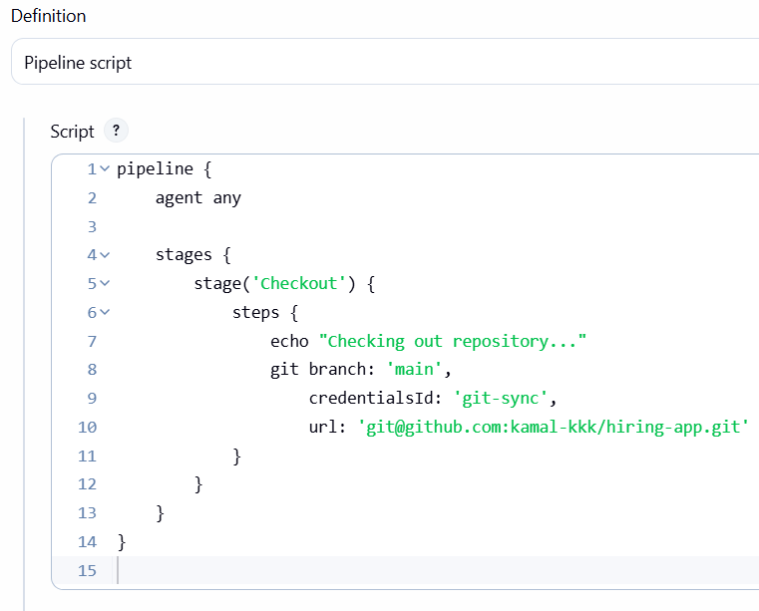
- pipeline {
- agent any

- stages {

- stage('Checkout') {
- steps {
- echo "Checking out repository..."
- git branch: 'main',
- credentialsId: 'git-sync',
- url: 'git@github.com:kamal-kkk/hiring-app.git'
- }
- }

- stage('Sonar Analysis') {
- steps {
- echo "Running SonarQube Analysis..."
- withCredentials([string(credentialsId: 'token', variable: 'SONAR_TOKEN')]) {
- withSonarQubeEnv('sonarqube') {
- sh """
- export PATH=\$PATH:/opt/sonar-scanner/bin
- sonar-scanner \
- -Dsonar.projectKey=hiring-app \
- -Dsonar.sources=. \
- -Dsonar.java.binaries=target \
- -Dsonar.host.url=http://3.90.217.124:9000 \
- -Dsonar.login=$SONAR_TOKEN
- """
- }
- }
- }
- }
- }
- }
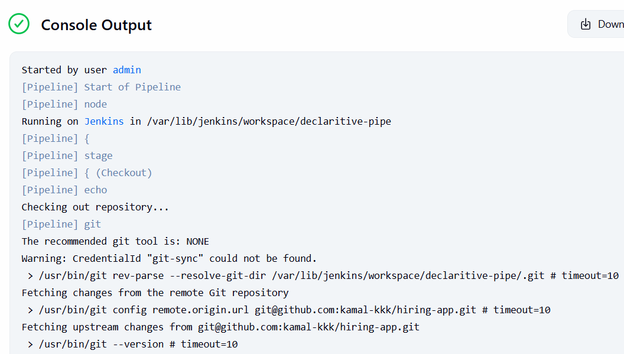
- Add maven
- pipeline {
- agent any

- tools {
- maven 'MVN_HOME' // <-- Your Maven name
- jdk 'JAVA17' // <-- Your JDK name
- }

- stages {

- stage('Checkout') {
- steps {
- echo "Checking out repository..."
- git branch: 'main',
- credentialsId: 'git-sync',
- url: 'git@github.com:kamal-kkk/hiring-app.git'
- }
- }

- stage('Sonar Analysis') {
- steps {
- echo "Running SonarQube Analysis..."
- withCredentials([string(credentialsId: 'token', variable: 'SONAR_TOKEN')]) {
- withSonarQubeEnv('sonarqube') {
- sh """
- export PATH=\$PATH:/opt/sonar-scanner/bin
- sonar-scanner \
- -Dsonar.projectKey=hiring-app \
- -Dsonar.sources=. \
- -Dsonar.java.binaries=target \
- -Dsonar.host.url=http://3.90.217.124:9000 \
- -Dsonar.login=$SONAR_TOKEN
- """
- }
- }
- }
- }

- stage('Maven Build') {
- steps {
- echo "Running Maven Build..."
- sh "mvn clean install"
- }
- }
- }
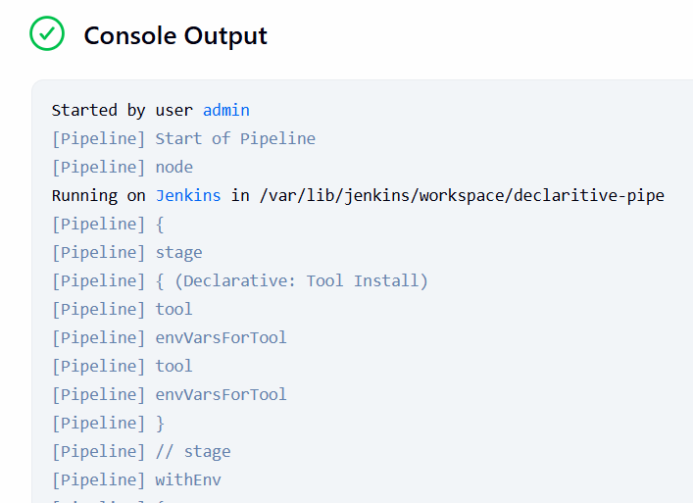
- Add nexus
- 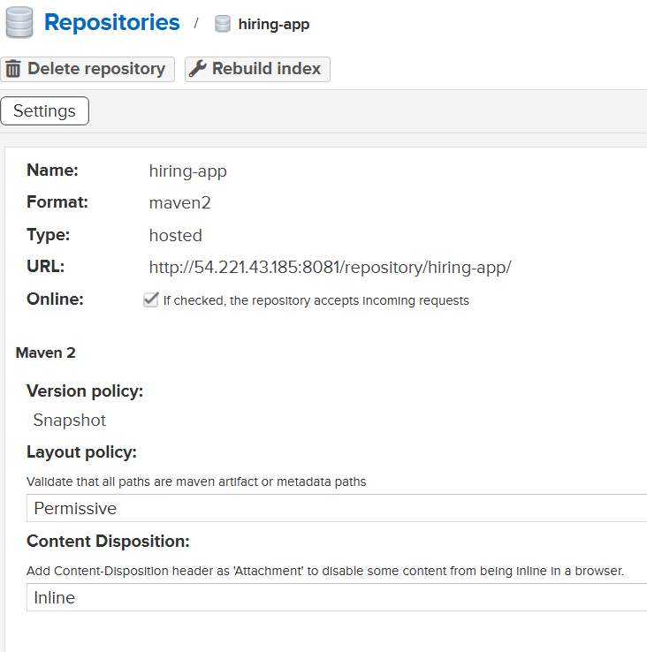
- pipeline {
- agent any

- tools {
- maven 'MVN_HOME'
- jdk 'JAVA17'
- }

- stages {

- stage('Checkout') {
- steps {
- echo "Checking out repository..."
- git branch: 'main',
- credentialsId: 'git-sync',
- url: 'git@github.com:kamal-kkk/hiring-app.git'
- }
- }

- stage('Sonar Analysis') {
- steps {
- echo "Running SonarQube Analysis..."
- withCredentials([string(credentialsId: 'token', variable: 'SONAR_TOKEN')]) {
- withSonarQubeEnv('sonarqube') {
- sh """
- export PATH=\$PATH:/opt/sonar-scanner/bin
- sonar-scanner \
- -Dsonar.projectKey=hiring-app \
- -Dsonar.sources=. \
- -Dsonar.java.binaries=target \
- -Dsonar.host.url=http://3.90.217.124:9000 \
- -Dsonar.token=$SONAR_TOKEN
- """
- }
- }
- }
- }

- stage('Maven Build') {
- steps {
- echo "Running Maven Build..."
- sh "mvn clean package -DskipTests"
- }
- }

- stage('Upload to Nexus') {
- steps {
- echo "Uploading artifact to Nexus..."
- sh """
- mvn deploy -DskipTests
- """
- }
- }
- }

- post {
- success {
- echo "Pipeline completed successfully."
- }
- failure {
- echo "Pipeline failed — check logs."
- }
- }
- }
- 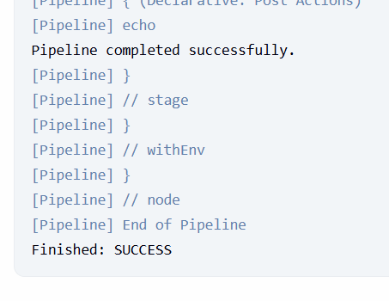
- Slack integration.
- 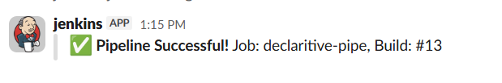
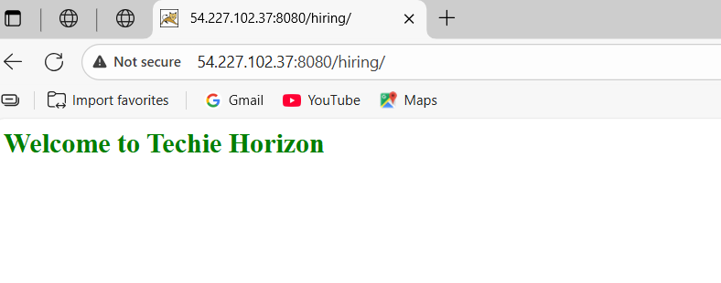
2 . Create one Scripted pipeline job
- New item
- Piple line
- Select scripted pipeline add script
- Add sonar credentials name and username
- Nexus repo
- node {

- // ============================
- // 1. TOOLS SETUP
- // ============================
- stage('Initialize Tools') {
- echo "Setting up Maven and Java"
- env.M2_HOME = tool 'MVN_HOME'
- env.JAVA_HOME = tool 'JAVA17'
- env.PATH = "${env.JAVA_HOME}/bin:${env.M2_HOME}/bin:${env.PATH}"
- }

- // ============================
- // 2. CHECKOUT FROM GIT
- // ============================
- stage('Checkout') {
- echo "Checking out code from Git"
- git branch: 'main',
- credentialsId: 'git-sync',
- url: 'git@github.com:kamal-kkk/hiring-app.git'
- }

- // ============================
- // 3. SONARQUBE ANALYSIS
- // ============================
- stage('Sonar Analysis') {
- echo "Running SonarQube Analysis..."

- withCredentials([string(credentialsId: 'token', variable: 'SONAR_TOKEN')]) {
- withSonarQubeEnv('sonarqube') {

- sh """
- export PATH=\$PATH:/opt/sonar-scanner/bin
- sonar-scanner \
- -Dsonar.projectKey=hiring-app \
- -Dsonar.sources=. \
- -Dsonar.java.binaries=target \
- -Dsonar.host.url=http://3.90.217.124:9000 \
- -Dsonar.token=$SONAR_TOKEN
- """
- }
- }
- }

- // ============================
- // 4. MAVEN BUILD
- // ============================
- stage('Maven Build') {
- echo "Running Maven Build..."
- sh "mvn clean package -DskipTests"
- }

- // ============================
- // 5. UPLOAD TO NEXUS
- // ============================
- stage('Upload to Nexus') {
- echo "Uploading artifact to Nexus..."

- withCredentials([
- usernamePassword(credentialsId: 'nexus-admin',
- usernameVariable: 'NEXUS_USER',
- passwordVariable: 'NEXUS_PASS')
- ]) {
- sh """
- mvn deploy \
- -DskipTests \
- -Dnexus.url=http://54.221.43.185:8081 \
- -Dnexus.repository=hiring-app \
- -Dnexus.username=$NEXUS_USER \
- -Dnexus.password=$NEXUS_PASS
- """
- }
- }

- // ============================
- // 6. DEPLOY TO TOMCAT
- // ============================
- stage('Deploy to Tomcat') {
- echo "Deploying WAR to Tomcat..."

- withCredentials([
- usernamePassword(credentialsId: 'tomcat-credentials',
- usernameVariable: 'TOMCAT_USER',
- passwordVariable: 'TOMCAT_PASS')
- ]) {
- sh """
- curl -v -u $TOMCAT_USER:$TOMCAT_PASS \
- --upload-file target/hiring.war \
- "http://54.227.102.37:8080/manager/text/deploy?path=/hiring&update=true"
- """
- }
- }
- }

- // ============================
- // 7. POST ACTIONS
- // ============================
- pipelineStatus = currentBuild.currentResult

- if (pipelineStatus == 'SUCCESS') {

- slackSend(
- channel: 'jenkins-integration',
- message: "✅ *Scripted Pipeline Successful!* Job: ${env.JOB_NAME}, Build: #${env.BUILD_NUMBER}",
- tokenCredentialId: 'slack'
- )

- } else {

- slackSend(
- channel: 'jenkins-integration',
- message: "❌ *Scripted Pipeline Failed!* Job: ${env.JOB_NAME}, Build: #${env.BUILD_NUMBER}",
- tokenCredentialId: 'slack'
- )
- }
- 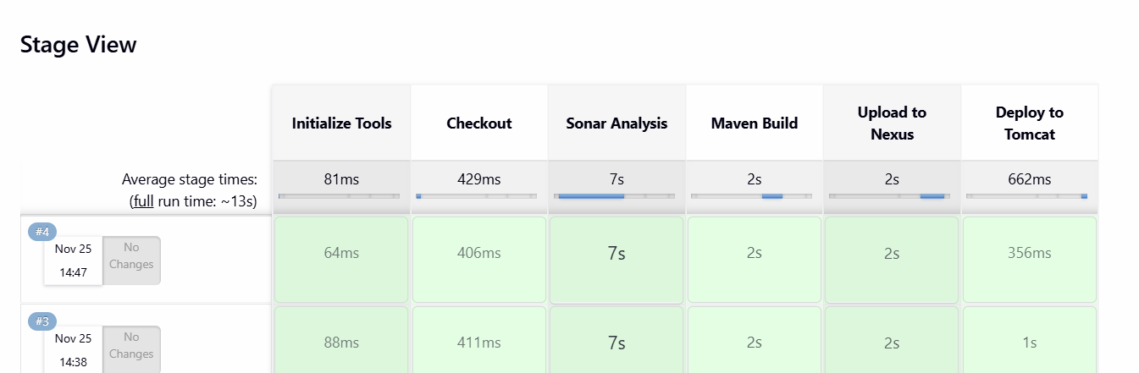
3 . Create one multistage pipeline job
- Create a job select pipe line
- Add git repo
- Give sonar credenitals id and user
- 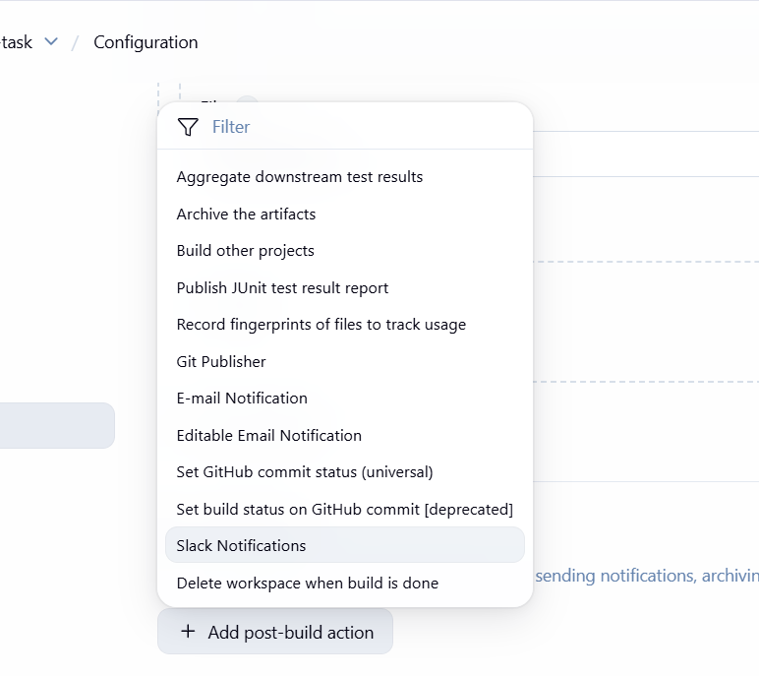
- And then nexus repo
- pipeline {
- agent any

- tools {
- maven 'MVN_HOME'
- jdk 'JAVA17'
- }

- environment {
- SONAR_HOST = "http://3.90.217.124:9000"
- NEXUS_URL = "http://54.221.43.185:8081"
- TOMCAT_URL = "http://54.227.102.37:8080"
- }

- stages {

- stage('Checkout') {
- steps {
- echo "Checking out repository..."
- git branch: 'main',
- credentialsId: 'git-sync',
- url: 'git@github.com:kamal-kkk/hiring-app.git'
- }
- }

- stage('Sonar Analysis') {
- steps {
- echo "Running SonarQube Analysis..."
- withCredentials([string(credentialsId: 'token', variable: 'SONAR_TOKEN')]) {
- withSonarQubeEnv('sonarqube') {
- sh """
- export PATH=\$PATH:/opt/sonar-scanner/bin
- sonar-scanner \
- -Dsonar.projectKey=hiring-app \
- -Dsonar.sources=. \
- -Dsonar.java.binaries=target \
- -Dsonar.host.url=$SONAR_HOST \
- -Dsonar.token=$SONAR_TOKEN
- """
- }
- }
- }
- }

- stage('Maven Build') {
- steps {
- echo "Running Maven Build..."
- sh "mvn clean package -DskipTests"
- }
- }

- stage('Upload to Nexus') {
- steps {
- echo "Uploading artifact to Nexus..."
- withCredentials([usernamePassword(credentialsId: 'nexus-admin',
- usernameVariable: 'NEXUS_USER',
- passwordVariable: 'NEXUS_PASS')]) {
- sh """
- mvn deploy \
- -DskipTests \
- -Dnexus.url=$NEXUS_URL \
- -Dnexus.repository=hiring-app \
- -Dnexus.username=$NEXUS_USER \
- -Dnexus.password=$NEXUS_PASS
- """
- }
- }
- }

- stage('Deploy to Tomcat') {
- steps {
- echo "Deploying WAR to Tomcat..."
- withCredentials([usernamePassword(credentialsId: 'tomcat-credentials',
- usernameVariable: 'TOMCAT_USER',
- passwordVariable: 'TOMCAT_PASS')]) {
- sh """
- curl -v -u $TOMCAT_USER:$TOMCAT_PASS \
- --upload-file target/hiring.war \
- "$TOMCAT_URL/manager/text/deploy?path=/hiring&update=true"
- """
- }
- }
- }
- }

- post {
- success {
- slackSend(
- channel: 'jenkins-integration',
- message: "✅ *Pipeline Successful!* Job: ${env.JOB_NAME}, Build: #${env.BUILD_NUMBER}",
- tokenCredentialId: 'slack'
- )
- }

- failure {
- slackSend(
- channel: 'jenkins-integration',
- message: "❌ *Pipeline Failed!* Job: ${env.JOB_NAME}, Build: #${env.BUILD_NUMBER}",
- tokenCredentialId: 'slack'
- )
- }
- }
- }
- 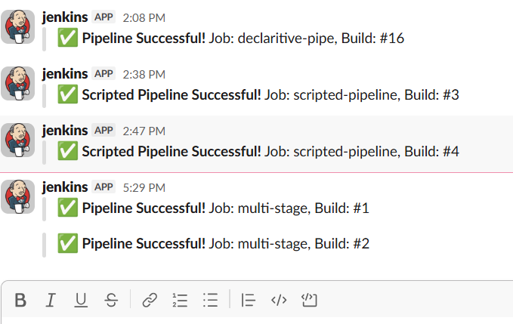
4 . create parallel stage pipeline.
- New item >
- Select pipeline
- Give git repo and add script
- pipeline {
- agent any

- stages {

- stage('Checkout') {
- steps {
- echo "Checking out code..."
- git branch: 'master',
- credentialsId: 'git-sync',
- url: 'git@github.com:kamal-kkk/VProfile-1.git'
- }
- }
- Adding parallel stage
- stage('Parallel Stages') {
- parallel {

- stage('Build') {
- steps {
- echo "🔧 Running Build Stage..."
- sh 'mvn clean install -DskipTests'
- }
- }

Total script
pipeline {
agent any

stages {

stage('Checkout') {
steps {
echo "Checking out code..."
git branch: 'master',
credentialsId: 'git-sync',
url: 'git@github.com:kamal-kkk/VProfile-1.git'
}
}

stage('Parallel Stages') {
parallel {

stage('Build') {
steps {
echo "🔧 Running Build Stage..."
sh 'mvn clean install -DskipTests'
}
}

stage('Sonar Analysis') {
steps {
echo "🔍 Running SonarQube Analysis..."
withCredentials([string(credentialsId: 'token', variable: 'SONAR_TOKEN')]) {
withSonarQubeEnv('sonarqube') {
sh '''
export PATH=$PATH:/opt/sonar-scanner/bin
sonar-scanner \
-Dsonar.projectKey=vprofile \
-Dsonar.sources=. \
-Dsonar.java.binaries=target \
-Dsonar.host.url=http://3.90.217.124:9000 \
-Dsonar.token=$SONAR_TOKEN
'''
}
}
}
}

stage('Security Scan') {
steps {
echo "🛡 Running Security Scan..."
sh 'echo "Security scan done"'
}
}

} // end parallel
} // end stage Parallel Stages

stage('Deploy') {
steps {
echo "🚀 Deploying application..."
sh 'echo "Deploy step completed."'
}
}
}

post {
success {
echo "✅ Pipeline completed successfully!"
}
failure {
echo "❌ Pipeline failed!"
}
}
}
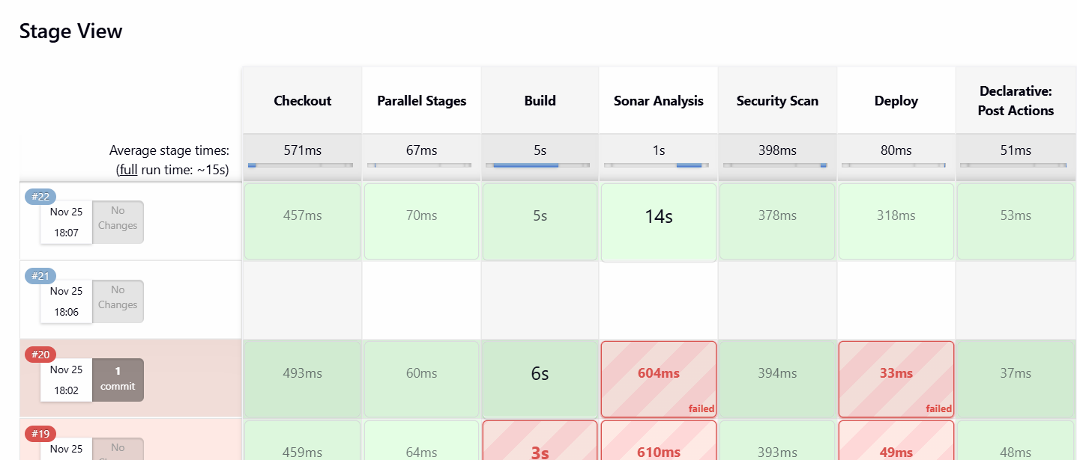
Successfully deployed in appache tomcat
LOGIN
